Home Learning Ideas – Week beginning 23rd March 2020
Colour and Shape
Books - Wow said the Owl and Brown Bear
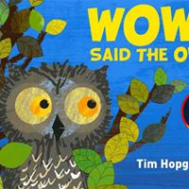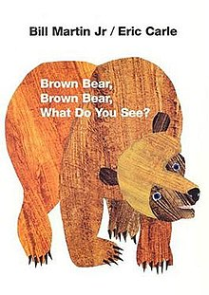
Activities
- Shape walk around the local area (if we are still allowed to go out), garden or house. Discussions and questions (can you see anything red, what shape are the car wheels etc)
- Finger painting (mix paint colours and explore what happens)
- Threading – making bead bracelets – talk about the patterns and colours
- Hopscotch game – use chalk to make one outside
- Set challenges – find something blue in the room, find 2 different shapes in the room and name them
- Shape and colour sorting and matching (see picture)

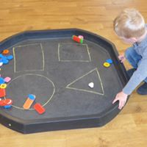

- Sequencing patterns with different coloured shapes, peg boards
- Shape jigsaw puzzles
- Colour and shape Potato printing
- Colour mix foam with food colouring or paint (explore what happens, making the colours darker, lighter etc – see picture) or put into freezer bags as a sensory activity
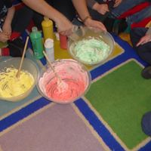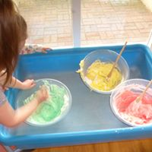

- Questions about their favourite colours, what colour are mummy’s eyes, daddy’s hair.
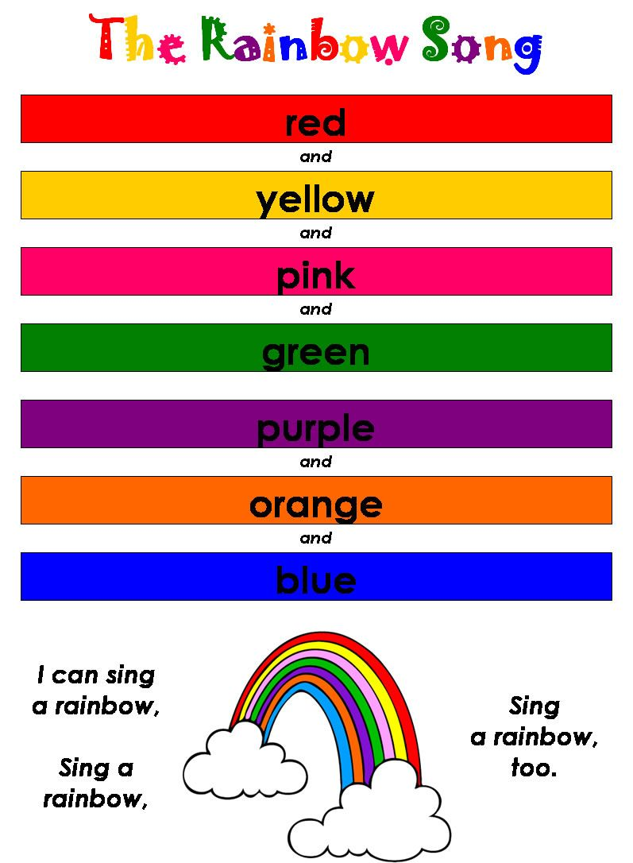
- A parent has also suggested we get the children to do rainbow pictures and put them in our windows so the local children can see them.
DON’T FORGET TO SEND ME ANY PICTURES OF YOUR CHILD DOING ANY OF THE ABOVE AND I WILL PUT THEM IN THE LEARNING JOURNALS xxxx

